Guide for electronically using the OOR uniform request form
- Go to the OOR website at http://openrecords.state.pa.us. Once there, click on the “Forms” section at the left-hand column.
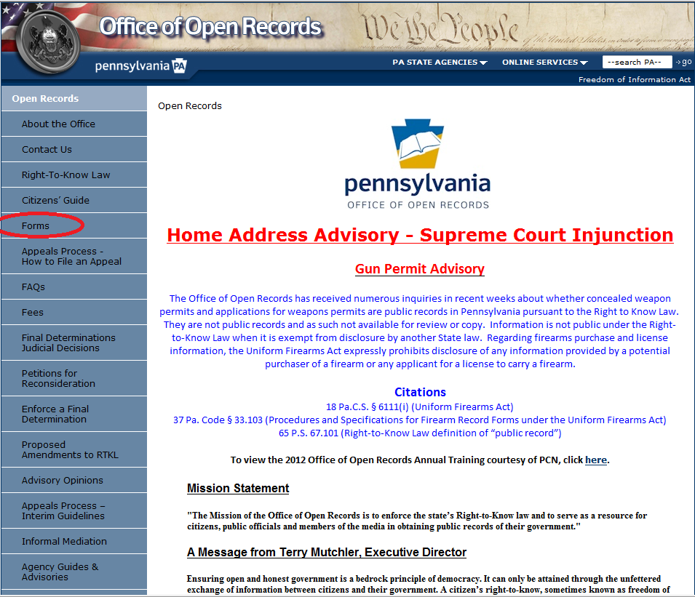

- Click on “Download PDF Form.” You must have Adobe Reader to open the PDF.
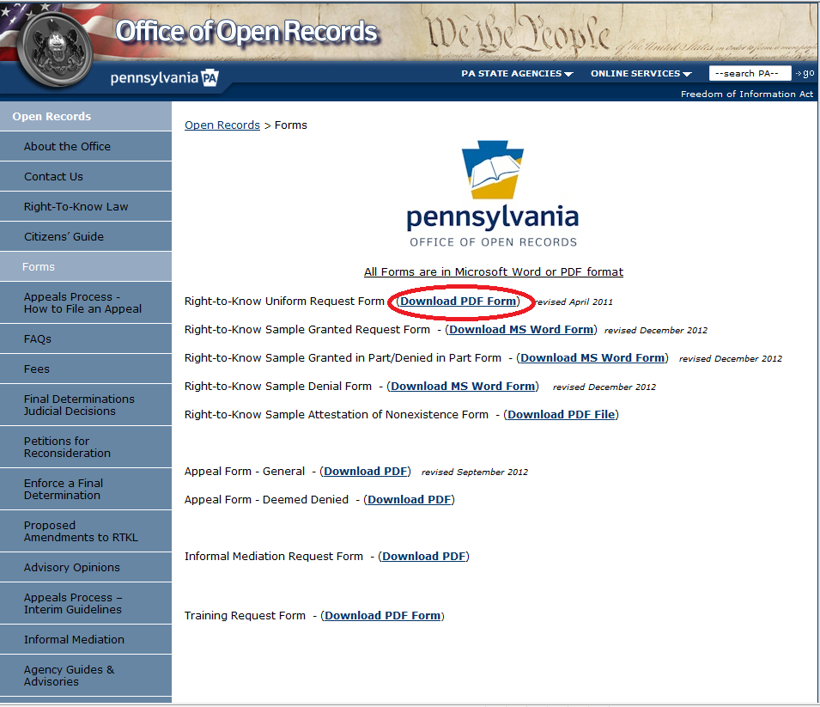

- If you click anywhere on the PDF, the following window may pop up. Click “Close.”
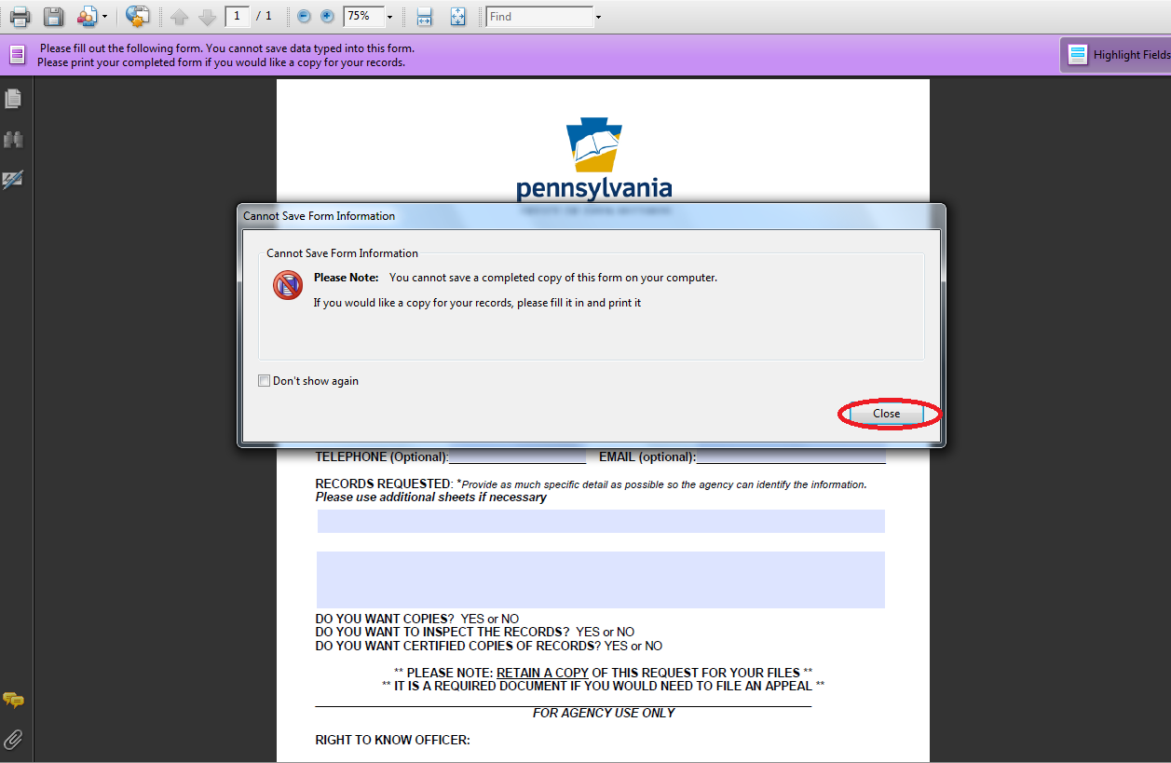

- Fill in the form and click on the printer icon at the upper left.
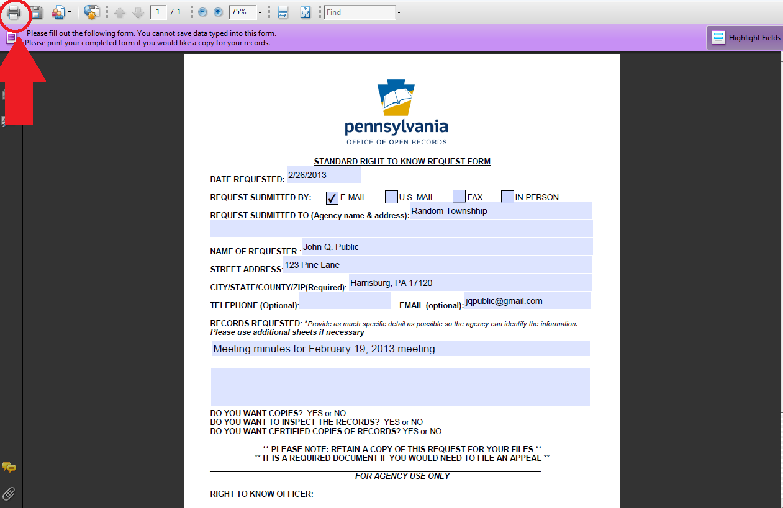

- A dialog box will pop up. Next to the printer name, click on the drop down arrow. Then click on “Microsoft Office Document Image Writer.” Then click “OK.”
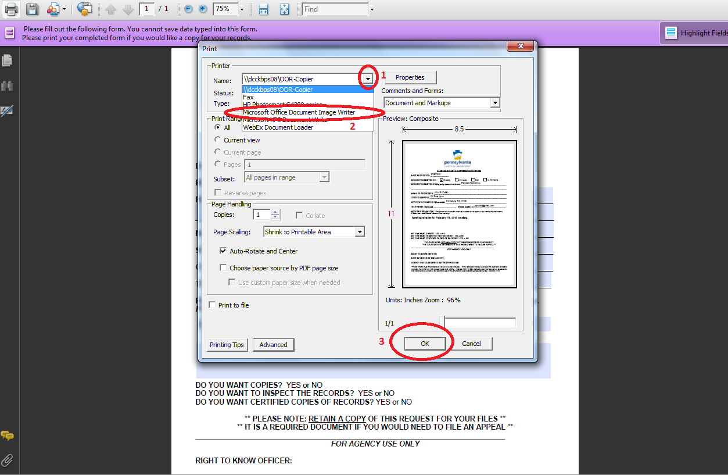

- Save your completed request form on your computer. As a default, it will save as a TIF file, which can be opened using the Paint program.
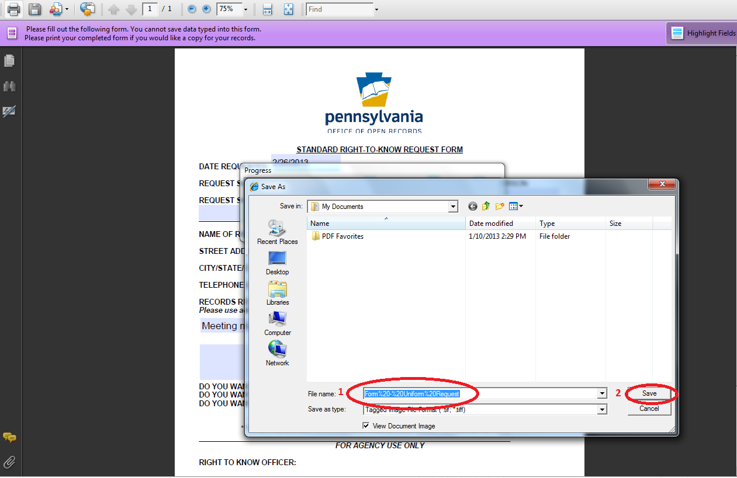
- Attach the TIF file to your e-mail to the agency’s open-records officer.

